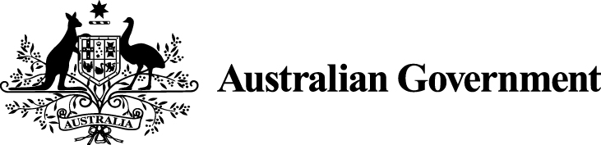

Australian Government submission on Ai Group proposal
- The Government acknowledges the challenges presented to the Fair Work Commission by the statutory requirement that the Annual Wage Review 2019-20 be completed by 30 June 2020. The unfolding coronavirus pandemic and its impact on domestic and global economies is unprecedented.
- The Government’s decision to delay the 2020-21 Budget reflects the significant challenges in making reliable, robust economic forecasts in the near future. However, it is clear that the economic impact of coronavirus, including on employment, will be significant.
- In light of rapidly evolving events relating to the coronavirus pandemic, the Government’s position is that the Commission should utilise any available mechanisms that enhance its ability to consider all economic data and other information relevant to the impact of the coronavirus pandemic when making its decision.
- The Government also notes that ‘exceptional circumstances’ provisions in ss 286(2) and 287(4) of the Fair Work Act 2009 enable the Commission, if exceptional circumstances are made out, to defer the commencement of any order (including a determination varying a modern award and a national minimum wage order) to an operative date after 1 July 2020.

